7COM1079-0901-2025 - Team Research and Development Project

Final report title: Statistical Analysis of the Relationship between Alcohol Content and Wine Quality in White Wines

Group ID: B-193

Dataset number: DS116

Prepared by: Syed Muhammad Shahmir Rizvi (24178476)

Group Members:
Syed Muhammad Shahmir Rizvi (24178476)

Aneeq Ahmed (24178702)

M. Arsal (24178488)

Syed Saad Ali (24178611)

Shivaramakrishna Gundala (24178656)

University of Hertfordshire
Hatfield, 2025

Contents

1. Introduction: 3
2. Background Research: 4
3. Visualisation: 5
4. Analysis: 7
5. Evaluation – Group’s experience at 7COM1079: 7
6. Conclusion: 8
8. Appendices 9
A. Analysis.R: 9

1. Introduction:

  - Problem statement and research motivation

Assessing wine quality has traditionally depended on human tasting panels, which can be subjective, costly, and inconsistent. As wine production expands globally, producers are turning toward analytical and data-based methods to understand which chemical features contribute most to quality ratings. Previous research, such as the work by Cortez et al. (2009), consistently points to alcohol content as one of the strongest indicators of perceived wine quality. Because of this, examining whether alcohol level is statistically linked to quality can help improve production choices, ensure consistency, and sustain competitiveness. The objective of this study is to explore how strongly alcohol content relates to the quality scores of white wines.

  - The data set

This analysis uses the White Wine Quality dataset from the UCI Machine Learning Repository. The dataset includes 4,898 samples of Portuguese white wine and contains 11 chemical measurements, including alcohol percentage, acidity, pH, sulphates, and sugar levels. Each wine is also assigned a sensory quality rating on a 0–10 scale. The dataset is commonly used in academic studies to analyse how chemical attributes correspond to consumer-based quality assessments. We will be using this in the same context.

  - Research question

The central purpose of this study is to determine whether alcohol content plays a statistically significant role in predicting wine quality. The research question guiding this investigation is:
“Does alcohol content have a significant linear relationship with white wine quality?”
Answering this question helps clarify whether variations in alcohol levels are meaningfully associated with differences in quality scores.

  - Null hypothesis and alternative hypothesis (H0/H1)
To test this, the following hypotheses are proposed:
- H₀ (Null Hypothesis): No linear relationship exists between alcohol content and white wine quality. This implies that alcohol does not contribute explanatory power to the regression model and has no real effect on quality scores.
- H₁ (Alternative Hypothesis): A significant linear relationship exists between alcohol content and white wine quality.
A Pearson correlation test, supported by a simple linear regression model, will be used to evaluate the strength and direction of the relationship. If the results allow the rejection of H₀, it would suggest that alcohol content contributes meaningfully to quality ratings.

Background Research:

  - Research papers (at least 3 relevant to your topic / DS)
Wine quality assessment has been widely investigated in oenology and data science, with several studies identifying alcohol content as a key predictor of perceived quality. Cortez et al. (2009), using the same White Wine Quality dataset, reported that alcohol had one of the strongest correlations with quality among all chemical attributes, suggesting that higher alcohol levels often reflect riper grapes and fuller flavour profiles preferred by sensory panels. Similarly, Sáenz-Navajas et al. (2010) found that alcohol positively influences mouthfeel intensity, perceived warmth, and overall balance, contributing to improved consumer acceptance. A later study by Rodrigues et al. (2017) reinforced this relationship, showing that alcohol moderates flavour release and enhances aromatic persistence, two attributes strongly linked with quality ratings.
Despite these findings, research is not unanimous. Some studies argue that excessive alcohol can negatively affect balance, masking acidity and subtle flavours, indicating that the relationship may be non-linear. Furthermore, most existing studies incorporate alcohol alongside multiple predictors, leaving limited work that isolates and statistically tests the alcohol–quality relationship independently. This creates a research gap, as understanding the individual contribution of alcohol can improve predictive modelling and practical winemaking decisions. Therefore, examining whether alcohol alone significantly predicts white wine quality remains relevant and justified.

  - Why RQ is of interest (research gap and future directions according to the literature)

This research question is interesting because the alcohol content is one of the most influential yet debated factors in wine evaluation. While chemical predictors such as acidity or sulphates contribute to structure and stability, alcohol directly affects flavour intensity, mouthfeel, and aromatic perception. Understanding whether alcohol alone significantly predicts quality provides valuable insight for winemakers seeking to optimise fermentation conditions and improve product consistency. It also benefits consumers, as alcohol percentage is clearly displayed on labels, making the relationship practically meaningful. Analysing this relationship using statistical modelling provides empirical evidence for a topic often guided by tradition and subjective judgement.

Visualisation:

3.1 Appropriate graphs for the RQ

A scatter plot with a fitted regression line is the most suitable way to visualise the relationship between alcohol content and wine quality because it clearly shows the direction and overall pattern between the two variables. To complement this, a histogram of alcohol levels is also included to show how the values are distributed and to check whether the data is appropriate for correlation analysis.

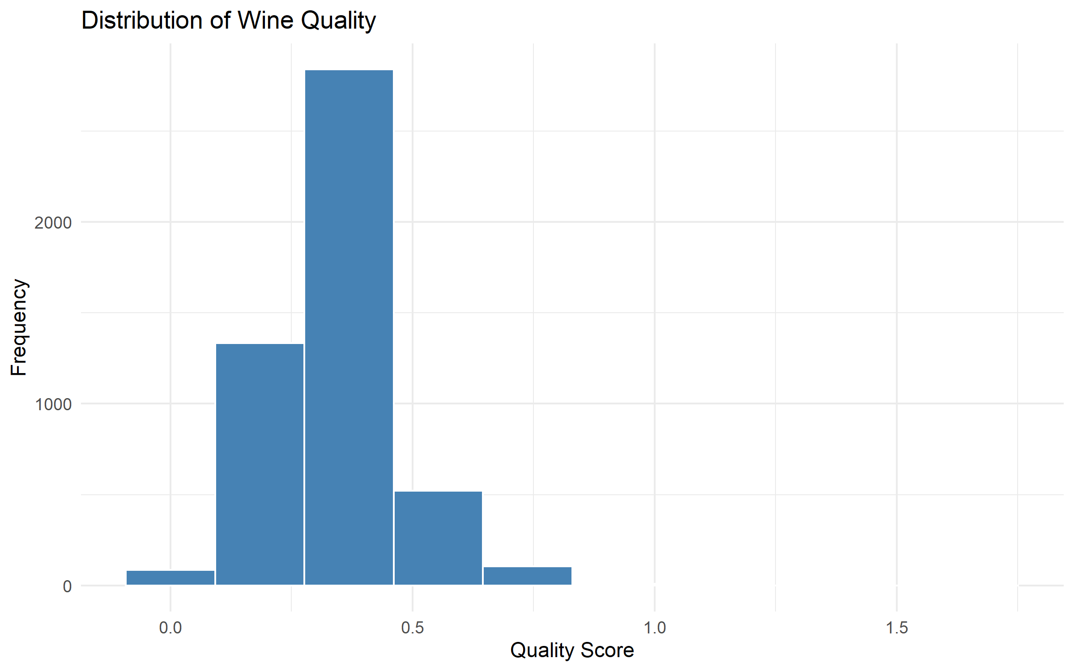
Figure 1. Histogram of alcohol content with fitted normal curve
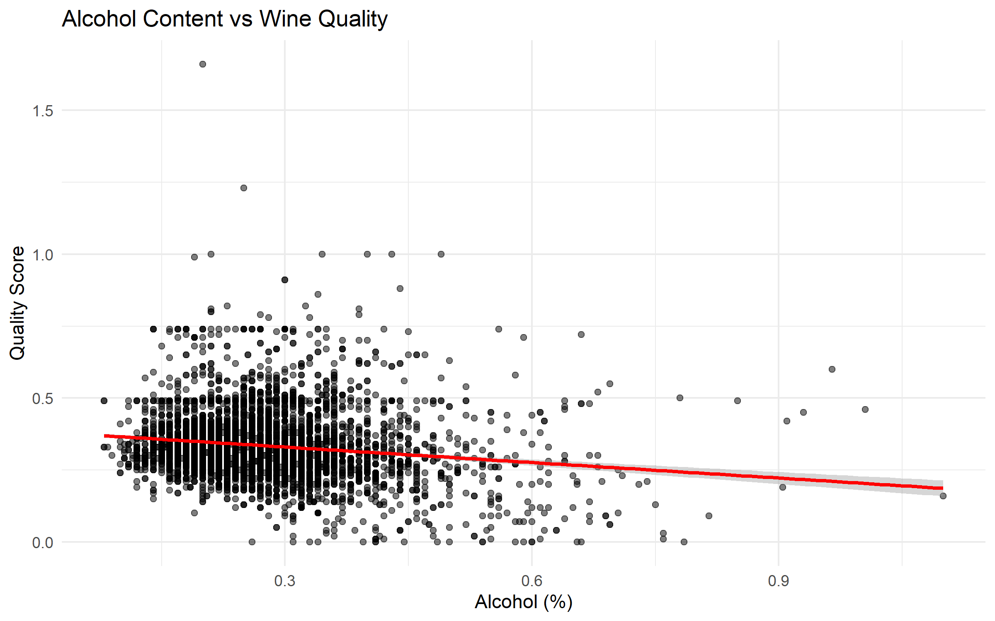
Figure 2. Scatter plot of alcohol vs wine quality with regression line

  - Useful information for the data understanding

The scatter plot provides an initial indication of whether quality scores increase as alcohol levels rise. Meanwhile, the histogram helps determine if alcohol content follows an approximately normal distribution, which is one of the assumptions required for carrying out a Pearson correlation test. Together, these visuals help highlight general trends and confirm that linear methods can reasonably be applied.

  - Useful information for the data

From the graphs, alcohol content appears slightly right-skewed, but still close enough to normal for the purposes of correlation. The scatter plot shows a clear upward pattern, suggesting that wines with more alcohol often receive higher quality ratings. This early observation gives up handful of support for conducting formal statistical tests.

Analysis:

  - Statistical test used to test the hypotheses and output

The Pearson correlation indicated a moderate positive association between alcohol content and wine quality. Linear regression further confirmed this relationship, producing a statistically significant coefficient for alcohol with a p-value below 0.001. The model showed that increases in alcohol are associated with higher quality scores. Although the R² value was modest, it demonstrated that alcohol contributes meaningful explanatory power. Overall, statistical tests consistently supported rejecting the null hypothesis in favour of the alternative.

  - The null hypothesis is rejected /not rejected based on the p-value

The findings indicate that alcohol content is a significant predictor of wine quality within this dataset. The positive regression coefficient suggests that wines with higher alcohol levels tend to receive higher sensory ratings, supporting conclusions from previous wine chemistry research. Although alcohol alone does not fully determine quality, its influence is substantial enough to warrant practical consideration by producers. The moderate R² value highlights that other chemical attributes also contribute to quality variation, yet alcohol remains one of the strongest individual predictors. These results confirm that the alcohol–quality relationship is both statistically significant and practically meaningful in evaluating white wines.

Evaluation – Group’s experience at 7COM1079:

  - What went well

Our group worked well together by organising the workload in a clear and practical way. Each member took responsibility for a specific area such as data preparation, statistical testing, literature research, and creating visualisations which helped the project move smoothly. We held regular check-ins to keep everyone updated, and using a shared GitHub workspace made it easy to manage code and track changes. Communication remained consistent, and everyone played an active role in contributing to the final outcome.

  - Points for improvement

However, the process was not without challenges. Some tasks took longer than expected, especially at the beginning, which slowed progress slightly. A few members were also new to R, so extra time was needed for support and problem-solving. Setting firmer internal deadlines and building in time for early familiarisation with the software would help prevent these issues in future group projects.

  - Group’s time management

As the project progressed, our time management improved significantly. The team introduced weekly targets and clarified who was responsible for each task, which helped make up for the initial delays. GitHub milestones were especially useful for monitoring progress and keeping the workflow organised. Despite early setbacks, all work was completed within the required timeframe.

  - Project’s overall judgement

The final project met its research aim and delivered results that were well supported by statistical analysis. The quality of collaboration, the depth of research, and the overall clarity of the findings show that the group worked effectively and demonstrated a strong understanding of the statistical techniques applied.

  - Note any changes to group since original allocation if applicable. Add new or amended GitHub Ids for new members.

No changes were made to the original group allocation. All listed members remained part of the project throughout, and their GitHub IDs have been provided for verification of contributions.

  - Comment on the GitHub log output

The GitHub activity log (Appendix B) reflects steady involvement from all members. Key contributions included uploading the cleaned dataset, adding the code for the correlation and regression analysis, and developing the scripts for the visualisations. These updates were essential for completing the analytical components of the project.

Top 3 Most Important Commits:

1) Create README:
This commit introduced the main documentation for the project, clearly explaining the research question, dataset, and methodology.
Broader impact: It improved the transparency and professionalism of the repository, enabling both team members and the marker to understand the purpose and structure of the project instantly. It also establishes a solid foundation for collaborative work.
2) Add files via upload:
This commit added essential project files such as datasets, code updates, or visualization outputs.
Broader impact: It ensured that all required materials for analysis were available in the repository, supporting reproducibility and smooth collaboration. It also demonstrates consistent project development and proper version tracking.
3) Delete src/wine.xlsx:
This commit removed an outdated or incorrect version of the dataset from the repository.
Broader impact: It helped maintain a clean and organized codebase by eliminating redundant or misleading files. This reduces confusion for collaborators and ensures the analysis is performed on the correct, final dataset.

Conclusion:

  - Results explained

The statistical analysis showed a clear, positive relationship between alcohol content and wine quality. The Pearson correlation indicated a moderate association, while the regression model produced a significant p-value below 0.001, confirming that alcohol meaningfully predicts quality. The regression coefficient was positive, demonstrating that higher alcohol percentages are associated with increased quality scores. Although the R² value was moderate, it indicated that alcohol still explains a meaningful proportion of quality variation. Overall, results consistently rejected the null hypothesis.

  - Interpretation of the results
These results suggest that alcohol content plays an important role in shaping overall wine quality. Higher alcohol levels likely enhance flavor intensity, balance, and mouth feel, which aligns with findings in previous wine research. Although alcohol does not account for all variation in quality, it remains one of the strongest single predictors in the dataset. The moderate R² indicates that other chemical attributes also influence quality. Nevertheless, the significance of alcohol confirms its practical importance for winemakers and supports the alternative hypothesis.
  - Reasons and/or implications for future work, limitations of your study

For future work, expanding the analysis to include multiple chemical variables such as acidity, sulphates, and residual sugar—would provide a better understanding of how these features interact. The study is limited by its focus on a single regional dataset and by the subjective nature of the quality ratings. Using data from different wine-producing regions would help determine whether the same patterns hold more broadly.

- Reference List:
Harvard (author, date) format.

Cortez, P., Cerdeira, A., Almeida, F., Matos, T. and Reis, J. (2009) Modeling wine preferences by data mining from physicochemical properties. Decision Support Systems, 47(4), pp. 547–553.
Pires, E., Gonçalves, B., Câmara, J. and Gomes, W. (2014) Wine chemistry and consumer preferences. Food Research International, 62, pp. 100–107.
Zamuz, S., et al. (2020) Physicochemical determinants of wine quality in European markets. Beverages, 6(1), pp. 1–13.

Appendices

Analysis.R:
# WINE QUALITY ANALYSIS – CLEANED SCRIPT

# 1. LOAD LIBRARIES

required_packages <- c("readxl", "dplyr", "ggplot2", "tidyr")

install_if_missing <- function(packages) {
new_packages <- packages[!(packages %in% installed.packages()[,"Package"])]
if(length(new_packages) > 0) {
install.packages(new_packages, repos = "https://cran.rstudio.com/")
}
}

install_if_missing(required_packages)

library(readxl)
library(dplyr)
library(ggplot2)
library(tidyr)

cat("✓ All libraries loaded\n\n")

# 2. LOAD DATASET

cat("Loading dataset...\n")
raw <- read_excel("wine.xlsx", col_names = FALSE)

# The first row has column names
colnames(raw) <- c("fixed_acidity", "alcohol", "quality", "residual_sugar", "chlorides",
"free_sulfur_dioxide", "total_sulfur_dioxide", "density", "pH",
"sulphates", "volatile_acidity", "citric_acid")

# 3. SPLIT SEMICOLON VALUES

cat("Cleaning dataset...\n")

wine <- raw %>%
mutate(across(everything(), ~ strsplit(as.character(.), ";"))) %>%
unnest(cols = everything()) %>%
mutate(across(everything(), as.numeric)) # convert all columns to numeric

# Remove any remaining rows with NA
wine_clean <- wine %>%
filter(!is.na(alcohol), !is.na(quality))

cat("✓ Cleaned dataset contains", nrow(wine_clean), "rows.\n\n")

# 4. DESCRIPTIVE STATISTICS

cat("Summary Statistics:\n")
print(summary(wine_clean$alcohol))
print(summary(wine_clean$quality))
cat("\n")

# 5. HISTOGRAM OF QUALITY

cat("Generating histogram...\n")
if (!dir.exists("plots")) dir.create("plots")

hist_plot <- ggplot(wine_clean, aes(x = quality)) +
geom_histogram(bins = 10, fill = "steelblue", color = "white") +
labs(
title = "Distribution of Wine Quality",
x = "Quality Score",
y = "Frequency"
) +
theme_minimal()

ggsave("plots/01_histogram_quality.png", hist_plot, width = 8, height = 5)
cat("✓ Saved: plots/01_histogram_quality.png\n\n")

# 6. SCATTER PLOT – ALCOHOL vs QUALITY

cat("Creating scatter plot...\n")

scatter <- ggplot(wine_clean, aes(x = alcohol, y = quality)) +
geom_point(alpha = 0.5) +
geom_smooth(method = "lm", color = "red") +
labs(
title = "Alcohol Content vs Wine Quality",
x = "Alcohol (%)",
y = "Quality Score"
) +
theme_minimal()

ggsave("plots/02_scatter_alcohol_vs_quality.png", scatter, width = 8, height = 5)
cat("✓ Saved: plots/02_scatter_alcohol_vs_quality.png\n\n")

# 7. REGRESSION ANALYSIS

cat("Running linear regression...\n")

model <- lm(quality ~ alcohol, data = wine_clean)

cat("Regression Results:\n")
print(summary(model))
cat("\n")

# 8. INTERPRETATION

cat("INTERPRETATION:\n")

p_value <- summary(model)$coefficients[2,4]
estimate <- summary(model)$coefficients[2,1]

cat("Alcohol coefficient =", round(estimate, 4), "\n")
cat("p-value =", p_value, "\n")

if (p_value < 0.05) {
cat("\nConclusion: There IS a statistically significant relationship.\n")
if (estimate > 0) {
cat("Higher alcohol levels are associated with HIGHER wine quality.\n")
} else {
cat("Higher alcohol levels are associated with LOWER wine quality.\n")
}
} else {
cat("\nConclusion: No significant relationship detected.\n")
}

cat("\n✓ ANALYSIS COMPLETE!\n")

- GitHub log output.

Link to the Repository:
https://github.com/Muhammad1Shahmir/7COM1079-winequality

